1. Research on one (1) improvisation artists’ and highlight his or her artwork. Using their artwork, answer this essay question. To what extent is art improvisation a form of various arts?

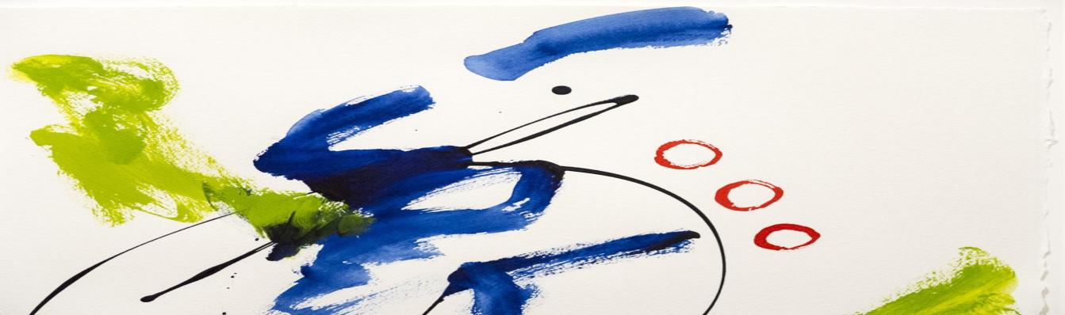

1. Is improvisation excellent or bad art? Why?

- I think this art would be bad for some perfectionist artist.

1. How do you use improvisation in everyday life?

-Giving the trust every day in life since Improvisation artist its all about trusting your self.

1. How good is it?

-not totally bad not totally good, its all about interpretation of the different people in art.